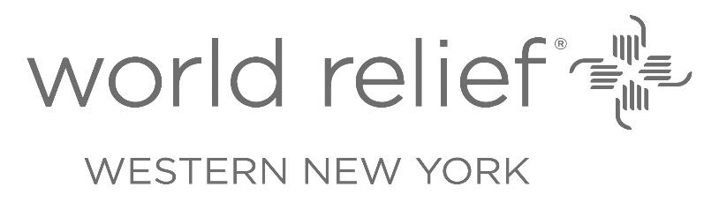
July 25, 2022

Diana Pryntz, Executive Director
Deaf Refugee Advocacy Inc
POB 10335
Rochester, NY 14610

Dear Ms. Pryntz:

World Relief Western New York is pleased to provide this letter in support of Deaf Refugee Advocacy (DRA)’s response to the Monroe County American Rescue Plan Act (ARPA) Funding Opportunities RFP. Since its formation, DRA has offered essential on-going community support for extremely at-risk citizens within the Monroe County area: deaf refugees, immigrants, and asylum-seekers (RIAs).

DRA’s project, if funded through the ARPA Funding Opportunity, will have a significant impact on reducing barriers faced by deaf, deafblind and hard-of-hearing RIAs that were made evident and exacerbated by the COVID-19 pandemic. These systemic barriers, which include but are not limited to language, cultural, and accessibility, can be overcome through DRA’s efforts to provide programming on language and cultural competency, health, safety, and employment to individuals and their families. As a result of these sign language-centric services, deaf RIAs' skills, support networks, and sense of belonging will increase, engaging them as equitable and contributing members of the Monroe County community.

Full funding of DRA’s ARPA submission will significantly meet the needs of a population that has been historically underserved, due to their unique intersectionality of people who are deaf, deafblind, and hard of hearing refugees, immigrants, and asylum-seekers. World Relief Western New York believes in the importance of DRA’s work and the ultimate impact it aims to achieve. By addressing these inequities, DRA’s transformational approach will ultimately benefit deaf RIAs, their families, and the community members, employers, and service providers they engage with, strengthening Monroe County for all.

World Relief Western New York is engaged in refugee resettlement in Monroe County, and looking forward to a deeper partnership with DRA as we welcome refugees from people groups known to have a high rate of hearing loss and impairment. Thank you for your support of DRA as they enhance and support our work among refugees.

Please do not hesitate to contact me if you have any questions.

Sincerely,
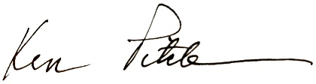

Ken Pitcher
Director, World Relief Western New York
420 Winton Rd. N, Rochester NY 14610
https://worldrelief.org/western-ny/
KPitcher@wr.org
585-532-7410

